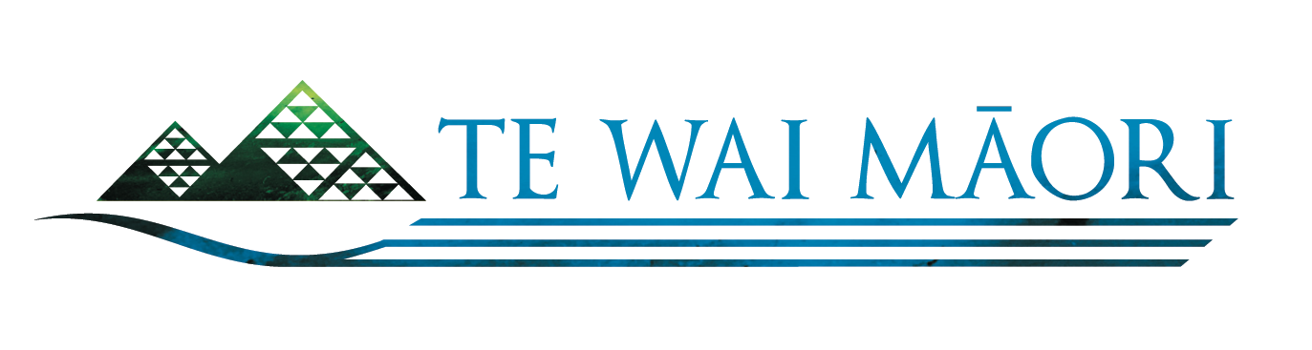

MEDIA RELEASE
25 June 2014

Water quality, quantity keys to restoring eel populations

NATIONAL EEL SYMPOSIUM 23, 24 JUNE ATTRACTS EXPERTS FROM THROUGHOUT AOTEAROA

Immediate and concerted national action is required to improve both the quality and quantity of water in New Zealand’s rivers and streams if our valuable eel populations are to be restored to healthy levels, the inaugural Māori Eel Symposium was told this week.

More than 160 eel management experts gathered at Hopuhopu, near Hamilton, to discuss sustainability and environmental concerns relating to New Zealand’s native eel populations.

The hui was hosted by Te Wai Māori Trust, which was created out of the Māori Fisheries Settlement to advance Māori interests in freshwater fisheries, in conjunction with the Waikato Raupatu River Trust, an entity of the Waikato-Tainui iwi.

Te Wai Māori Trust chairman, Ken Mair, said the two-day symposium attracted huge interest from people all over the country who are passionate about restoring our eel populations to good health. “This was an extremely valuable symposium and one which strongly emphasised that water quality and quantity will play a major role in the restoration of our eels. If we don’t get those two things right, then it doesn’t matter what we do with the eels because we just won’t fix the problem,” Ken said after the hui.

The symposium attracted a mix of iwi, commercial and customary fishing interests, scientists and policy advisers from central and local government, independent experts and scientists, hydropower generators and NGOs, but most importantly those who attended were some of New Zealand’s most experienced and knowledgeable eel experts passionate about eel conservation, he added.

The hui was held in response to calls from commercial and customary interests for action to be taken to improve the environment for our eel populations, which have been declining over some years. In April last year, the Parliamentary Commissioner for the Environment concluded in a report that the eel was on the path to extinction and called for urgent action to be taken to reverse the situation.

Ken said that iwi representatives from all over the country delivered informative presentations on work to replenish local eel populations, and which highlighted the value of traditional Māori management. Scientific papers were also presented by managers and scientists from the Ministry for Primary Industries, NIWA and the Department of Conservation.

Managers from regional and district councils were also present, as were eel industry representatives from the North and South Island commercial industries. Independent experts and scientists working on a variety of initiatives also provided detailed presentations. (Please see our website for a list of organisations that attended this symposium. Presentations can be downloaded here.)

Eels are significant as a food source and an important commercial fishery. Eels are also associated with the wider health of our freshwater environments and are considered as a proxy, or environmental sentinels, for the well-being of our inland waterways. “As a species, their cycle of life is geographically remarkable as it is challenging in the 21st century,” Ken says.

There are numerous threats to the eel during their lifespan – loss of habitat through land use change, diversion of rivers and streams, dams, as well as erosion and the clearing of forests, which causes silt and sediment to build up over our riverbeds. Such barriers contribute to preventing young elvers from completing their upstream migration. New Zealand’s hydroelectric power stations and turbines are a threat to adult eels making their way back to the Pacific breeding grounds; and the commercial management of eels continues to be a major challenge.

“We all have an interest in ensuring our eel populations remain healthy and abundant, so that they can meet the needs of the customary, commercial and recreational fishing sectors. Iwi can play a key role and this symposium is just one example of how all the various sectors are able to work together to improve eel management,” Ken says.

“Te Wai Māori Trust is committed to delivering on the outcomes of this symposium, and build on the goodwill demonstrated by all who attended,” he added.

For more information and interviews, contact Ken Mair on 027 467 7071 or contact Doug Jones at Te Wai Māori Trust on 04 931 9509.

